23.3: a)
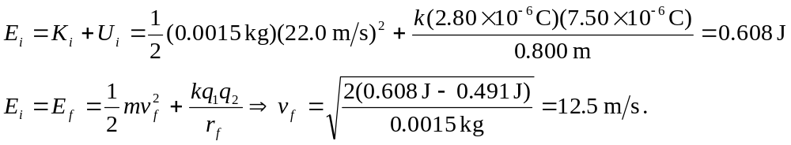
b) At the closest point, the velocity is zero:
